Confidential and Proprietary Information
(c) 2003-2004 CONCEPT DEVELOPMENT GROUP
Please protect this information.
- This is a picture of plate with one strain gage accessed
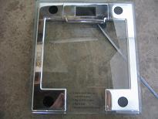
- This is another stain-gauge force sensor that I had built myself. It works. But it may be easier to convert a commercial scale like above. When it comes to bulk manufacturing, we can redesign our own.
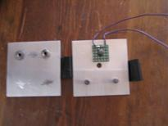
- This is the interface (evalution board) . Interfaces to PC via serial port. From jumbers I connect to strain gauge from ig 1. I would need 4 of these. So for the first prototype it is easier to make by using muliple serial port cards and use 4 indepnedent interfaces.
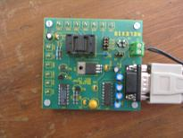
- The digitized value of the strain is read into the PC by the software provided by the IC manufacturer Melexis. I have the schematics. I have the source codes also. The values extracted from the stain gauge are displayed as the following format in the PC.
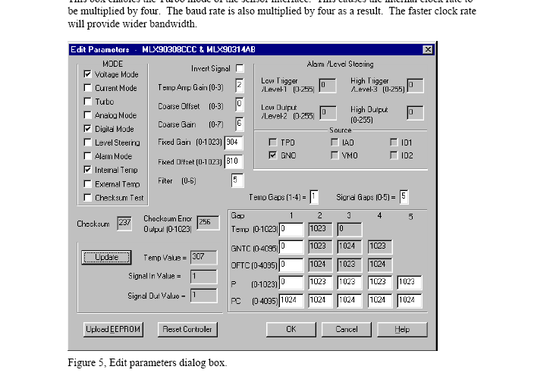
a
b
- Our software requirements
  - We want the initial software to
    - push the button marked “a” in above fig to updated the value of the stain gauge
    - read the digitized value “signal out Value” marked by “b” in above fig
    - Store in a spread sheet or a memory location so that another application program can access
  - The final program or the application program should ( al later stage)
    - Do above algorithm for three other stain devices
    - Read and do the mathematical computation with above four values to come up with COG: two number X(t) and Y(t)
    - Display a dot on the display screen at the coordinated X(t) and Y(t)
  - Later we would like to play with the other parameters in the above Fig from the application program
- In the accompanying attachment, I am attaching the user manual/datasheet for this interface board
- When the time comes, I can supply the source codes (C++) for the interface.

